Create a class Beverages,the Tea and Coffee sub classes are using the common method addMilk and they are implementing abstract method void addIngredient.

Implementing Accessibility of members across packages and classes

1.public function in same class

2. calling from one package from other with public

create a PrivateAccess class, private data members when we are trying to call the private data member and method of a PrivateClass class it gives us a compile-time error because private data members and methods have an access level to PrivateClass class only.

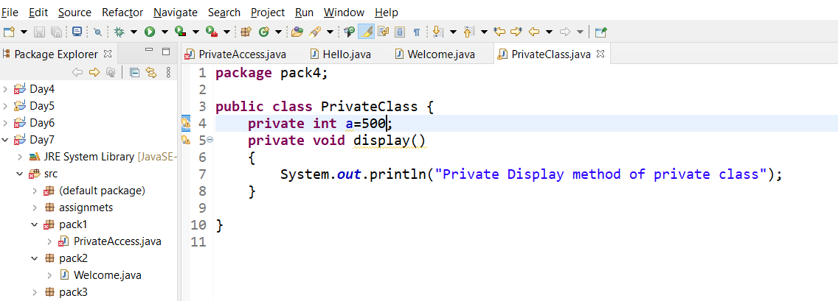

create a class ProtectedClass under a package pack1 in which we declare a protected method show(), create a class ProtectedAccess under a package mypack1 and import a package pack1.

